Observer Design Pattern in Java
Observer design pattern is useful when you are interested in the state of an object and want to get notified whenever there is any change. In observer pattern, the object that watch on the state of another object are called Observer and the object that is being watched is called Subject.
Define a one-to-many dependency between objects so that when one object changes state, all its dependents are notified and updated automatically.
Subject contains a list of observers to notify of any change in its state, so it should provide methods using which observers can register and unregister themselves. Subject also contain a method to notify all the observers of any change and either it can send the update while notifying the observer or it can provide another method to get the update
Java provides inbuilt platform for implementing Observer pattern through java.util. class and java.util.Observer interface. However it’s not widely used because the implementation is really simple and most of the times we don’t want to end up extending a class just for implementing Observer pattern as java doesn’t provide multiple inheritance in classes.
Java Message Service (JMS) uses Observer design pattern along with Mediator pattern to allow applications to subscribe and publish data to other applications.
Model-View-Controller (MVC) frameworks also use Observer pattern where Model is the Subject and Views are observers that can register to get notified of any change to the model.

Java Observer Pattern Class Diagram

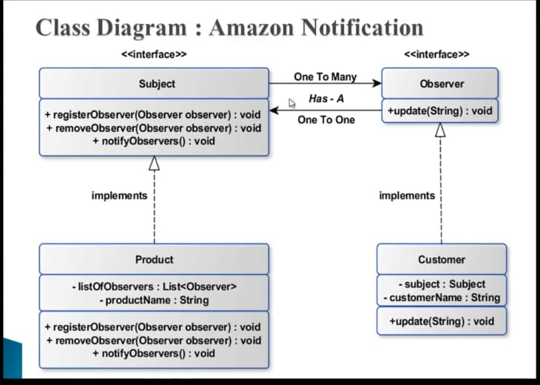

Observer design pattern is also called as publish-subscribe pattern. Some of it’s implementations are;

- java.util.EventListener in Swing
- javax.servlet.http.HttpSessionBindingListener
- javax.servlet.http.HttpSessionAttributeListener

For our observer pattern java program example, we would implement a simple topic and observers can register to this topic. Whenever any new message will be posted to the topic, all the registers observers will be notified and they can consume the message.

Example
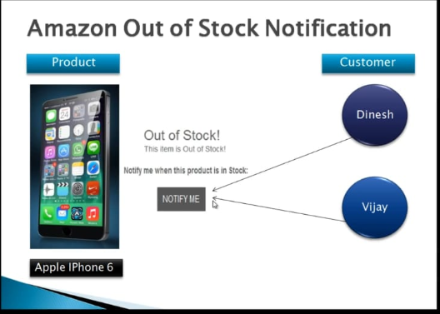

package com.test.mydesignpattern;

public interface Subject {
public void registerObserver(Observer ob);
public void removeObserer(Observer ob);
public void notifyMe();
}

package com.test.mydesignpattern;

public interface Observer {
public void update(String productName);
}

package com.test.mydesignpattern;

import java.util.ArrayList;
import java.util.List;

public class Product implements Subject {

private List<Observer> listOfObserver = new ArrayList<>();
private String productName;

private boolean avialable;

public boolean isAvialable() {
return avialable;
}

public void setAvialable( boolean avialable ) {
this.avialable = avialable;

if( avialable )
notifyMe();
}

public List<Observer> getListOfObserver() {
return listOfObserver;
}

public void setListOfObserver( List<Observer> listOfObserver ) {
this.listOfObserver = listOfObserver;
}

public String getProductName() {
return productName;
}

public void setProductName( String productName ) {
this.productName = productName;
}

@Override
public void registerObserver( Observer ob ) {
listOfObserver.add( ob );

}

@Override
public void removeObserer( Observer ob ) {
listOfObserver.remove( ob );
}

@Override
public void notifyMe() {
listOfObserver.stream().forEach( e -> {
e.update( productName );
} );
}

}

package com.test.mydesignpattern;

public class Customer implements Observer {

private Subject subject;
private String customerName;

public Subject getSubject() {
return subject;
}

public void setSubject( Subject subject ) {
this.subject = subject;
}

public String getCustomerName() {
return customerName;
}

public void setCustomerName( String customerName ) {
this.customerName = customerName;
}

@Override
public void update( String productName ) {
System.out.println("Hello "+customerName +" "+productName +" is avialable for shopping");
}

}

package com.test.mydesignpattern;

public class TestObserver {

public static void main(String args[]){

Customer c1 = new Customer();
Customer c2 = new Customer();

c1.setCustomerName( "Vikas" );
c2.setCustomerName( "Vimlesh" );

Product iphone6 = new Product();
iphone6.setProductName( "Iphone 6" );

iphone6.registerObserver( c1 );
iphone6.registerObserver( c2 );

iphone6.setAvialable( true );

iphone6.removeObserer( c2 );

System.out.println("**************************");
iphone6.setAvialable( true );

}

}

